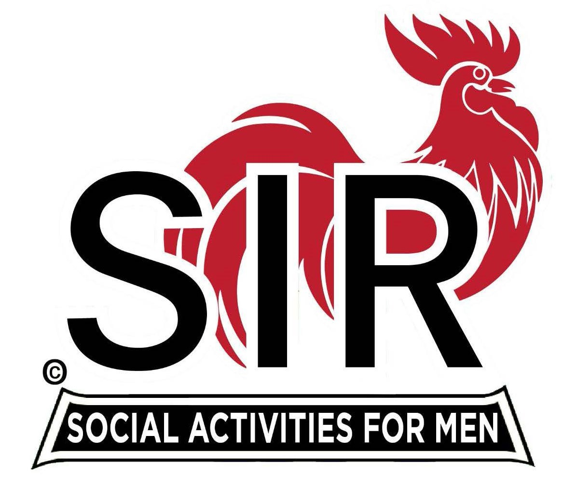
Las Trampas Branch 116
BEC Meeting Agenda
July 17, 2023, 9:15 AM at Boundary Oak

The Mission of SIR is to enhance the lives of our members through fun activities, events and luncheons while making friends for life.

9:15 am Call to order; Secretary, Paul Ramacciotti – Confirm quorum and
Approval of June 19, 2023 BEC meeting minutes

9:20 am Standing Reports

- Treasurer – Al Satake, Alan Fitzgerald

- Luncheon Report – Mike Schneider

- July 17 Boundary Estimated Count

- Membership – Phil Goff

4. RAMP Department Head Reports:

- Recruitment –
- Activity Coordinator – Mike Ward
- Member Relations - Michael Barrington
- Publicity – Paul Russell

9:40 am Little SIR Updates – Alan Pope

- Speaker Info – Jamal Hassan
- Birthday Boys – July

9:50 am Updates & New Business

- Director/Officer Slate – Fred Wachowicz
- No Show/No Dues – Big Sir
- Farmer’s Market – Big Sir
- Recipe Cards – Big Sir

10:15 am Adjourn: Lunch Preparations

